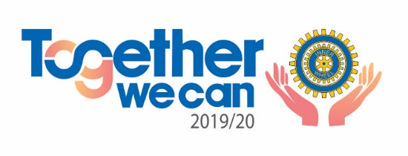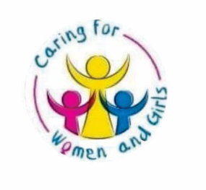

**Table of contents**

**-History of inner wheel**

**-Message from IIW President**

**-Message from Nat. Rep/President, Kemi Adeyemi**

**-Message from coordinator WFA 4, P IIW BD Adedoyin Abiodun-Oredein**

**-Keynote address from P IIW President, Oluyemisi Alatise**

**-Community Outreach: Caring for the Girl Child**

**Rational Drug Use**

**Domestic Violence**

**-Core Papers: IW Etiquette and Comportment**

**Sleep Disorder**

African Woman- Privileges and Challenges

 ..... Agonies of Domestic Violence

.... Hazards of Teenage Pregnancy

.... Role of Education - Culture & Change

**-COMMUNIQUE**

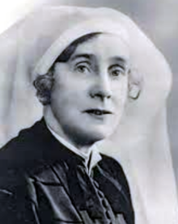

**WOMEN FOR AFRICA 4**

History of Inner Wheel

Mrs. Oliver Golding

Magerette Owen, later Mrs. Oliver Golding, the wife of Manchester Rotarian was born of Welsh parentage at Hey Brecon, her father stated the Gas produce works which he stabilized by undertaking and accomplishing great feats. He spent the rest of his life in that business, Prior to Mrs. Oliver Golding 's marriage she was trained as a nurse and became a sister at the London Hospital for Tropical Diseases, she retired later, but resumed her profession during the 1914 - 1918 war.

Subsequently, she joined two other ladies who already conducted a business in the manufacture of nurses uniforms, eventually purchasing all shares becoming governing director and renaming the business, “The Nurse”, A great philanthropist, her chief social interest being the Manchester Girls' Orphanage, and Ascots Hospital for which the Inner Wheel Club of Manchester provided and furnished mortuary chapel. She also did a great deal for the Girls Guide Movement, in which she held the office of Commissioner. There is no doubt that in Mrs. Golding, Inner Wheel found the right leader at the right time. Even though without her, there would certainly have been a much slower pace and the achievement of unity would have been much more difficult. She formed, directly, and personally, numerous clubs and several Districts.

Her inspiration is remembered to this day; she successfully achieved an even harder task in persuading members to look beyond their local concerns and become part of a much greater whole. if one small criticism may be made of such gifted work, it is that in their anxiety to save the members' pockets, and let nothing interfere with the formation of Districts and Association, she called for absolute minimum contribution which was a mere fraction of what was at the moment, spent on other objects. Thus, the first Capitation fee of the association was six pence per annum and remained at this for several years. Although the policy of frugality was one, it was sometimes carried to such extremes as to retard the development of the Association, especially in the establishment of headquarters and permanent staff.

All the attributes of a varied life were brought by Mrs. Golding to the services of Inner Wheel, the devotion of marriage, the practical helpfulness of the nurse, the acumen of the businesswoman, the vision of the public benefactors, great attributes indeed. Even the facilities of her commercial enterprises were utilized for extending the association. At her factory at Stockport, thousands of yards of material were provided and cut out to be made into garments for crippled children and needy persons by the members of the Manchester Club, a type of service work which was pursued by this and other clubs for many years. Oliver Golding was a vital personality combined with a clear brain and the ability to motivate and bring up others, she was an excellent Speaker and had a lively sense of humor, which enriched her words. Nature had endowed her with the gift of inspiring friendship and even devotion. Her special attribute was courage and courage was what inner Wheel needed in the beginning. She was undeterred by material difficulties, inertia or open hostility, and perceiving her object clearly before she went unhesitatingly towards it seeing Inner Wheel firmly established during her lifetime upon the path which it was to follow thereafter. The same courage sustained her through six years of illness, and she bore her suffering with great fortitude. Her death on May 2nd ,1939 was a grievous and untimely end to a life devoted to the service of other.

An extract from “Home and Horizon” By MILLICENT GASKILL

Message from IIW President



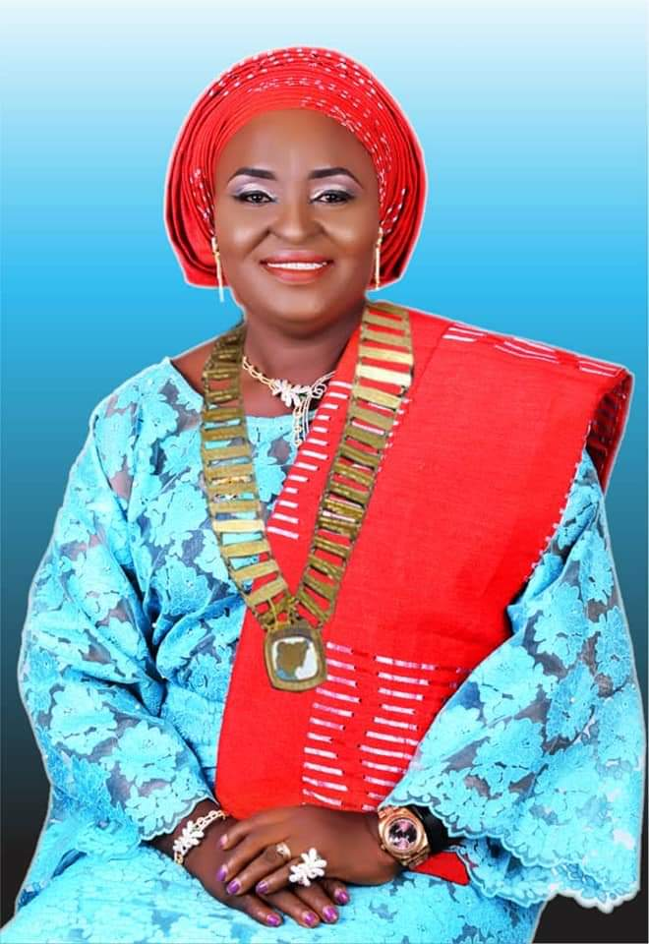

AN ADDRESS BY ADEKEMI ADEYEMI NATIONAL REPRESENTATIVE/ PRESIDENT OF INNER WHEEL CLUBS IN NIGERIA AT THE WFA4, HELD IN SHAGAMU, OGUN STATE

PROTOCOL

THE COORDINATOR WFA4

IIWPP OLUYEMISI

NGB EXECUTIVES

NATIONAL REPRESENTATIVE FOR INNER WHEEL CLUBS OF FRANCO FOME

DISTRICT CHAIRMAN FROM ABIDJAN

PAST NATIONAL REPs

PAST DISTRICT CHAIRMEN

Beautiful Inner Wheel Sisters from Africa

It is with utmost delight and immense pleasure that I welcome everyone to the 4th Edition of WOMEN FOR AFRICA CONFERENCE where we will be discussing on THE ROLE OF INNER WHEEL IN THE 21ST CENTURY.

I can say without a measure of doubt that it is a big privilege and honor to be here today in Shagamu, Ogun State. Nigeria.

Big congratulations to the initiator of this programme for their vision and the courage to start the WOMEN FOR AFRICA SEMINAR in Nigeria, the fruits which we are all enjoying today.

As we all know, Inner Wheel is a non-religious, non- governmental and non- profitable making organization. We try to build bridges and relationships with an eye on the future. The Theme for the Inner Wheel year is "Together We Can" and the sub-theme is "Caring for the Women and Girls."

The WFA, Women for Africa Seminar was started in Nigeria in November 2012 by our PIIWP Oluyemisi Alatise. It focuses on bettering ourselves through dialogue, enlightening and broadening our horizon through information sharing and exchanging views on how to better provide solutions to reduce the gap between the haves and have not's.

I hope the discussion on all the topics in the seminar will open our minds and enable us impact others through our various awareness programmes.

We shall also continue to learn from each other as we exchange views from time to time.

I want to encourage our sisters from other countries to take the challenge to host WFA6. Together We can make it happen

In the course of the seminar, we will be listening to lectures and inspirational topics from our high and quality speakers and I am absolutely sure that we will not only be inspired to do more but we will discover and learn new and innovative ideas which we will take back to our various locations and implement.

Also, I want to congratulate the coordinator of this programme, PBD Doyin Abiodun Oredein, DC Jumoke Odulaja and all the committee members for their selfless work. I also greatly appreciate our sisters from West Africa for their invaluable presence here.

To you my beautiful Inner Wheel Sister's all over the Country, I say a massive thank you for your great contributions!

Once again, I thank all Participants, Moderators, Secretaries, Lecturers, Committee Members, Special Guests and fellow Inner Wheel members.

Together We Can change World.

Together We Can empower the needy.

Together We Can take Inner Wheel to a greater height.

Together We Can!

Thank you all.

Yours in True Friendship

**Adekemi Adeyemi**

National Representative/President of Inner Wheel Clubs in Nigeria 2019/2020

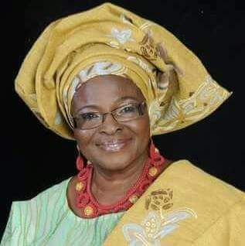

Welcome address at the WFA4

It gives me great pleasure to welcome everyone here present today on behalf of the National Governing Body of Inner Wheel Clubs in Nigeria, ably headed by the National Representative & President Princess Adekemi Adeyemi.

We have successfully organized three editions of this conference tagged 'Women for Africa: Role of Inner Wheel. This is the fourth edition holding in this ancient town of Sagamu Reno. It is aimed to project, examine and assert the challenges, motivation and cultural changes surrounding the African Woman and her desire to positively impact her world while critically considering her numerous and enormous inter woven roles right down to her limitless and not to be hindered growth.

We are particularly privileged to have very distinguished erudite professionals to handle the topics that daily affect the African Woman and the Girl Child. I am positive we all have a lot to gain from the lectures...

.... Rational Drug Use

.... African Woman: Health Promotion and

              Harmful Practice

......Sleep Disorders

......African Woman- Privileges and Challenges

 ......Agonies of Domestic Violence

......Protecting the Girl Child

.... Hazards of Teenage Pregnancy

.... Role of Education - Culture & Change

At this point I will like to appreciate Prof EbunOluwa Oduwole DVC (Admin) OOU for her relentless efforts in sourcing and selection of able facilitators for most of the topics

I welcome our Royal Father the special guest of honor, special guests, awardee, all invited guests and of course our own pride PIIWP Oluyemisi Alatise's who will deliver the keynote address

My fellow Inner Wheel friends I welcome you all very warmly, despite the volatile  economic disruptions in the country, your devotion and commitment to serve mankind brought you here today from outside and within Nigeria because Together We Can Make a Remarkable Difference and Make The World A Better Place

I wish us pleasurable experience while we deliberate fruitfully

Thank you and God bless

Doyin Abiodun-Oredein

PIIW BD

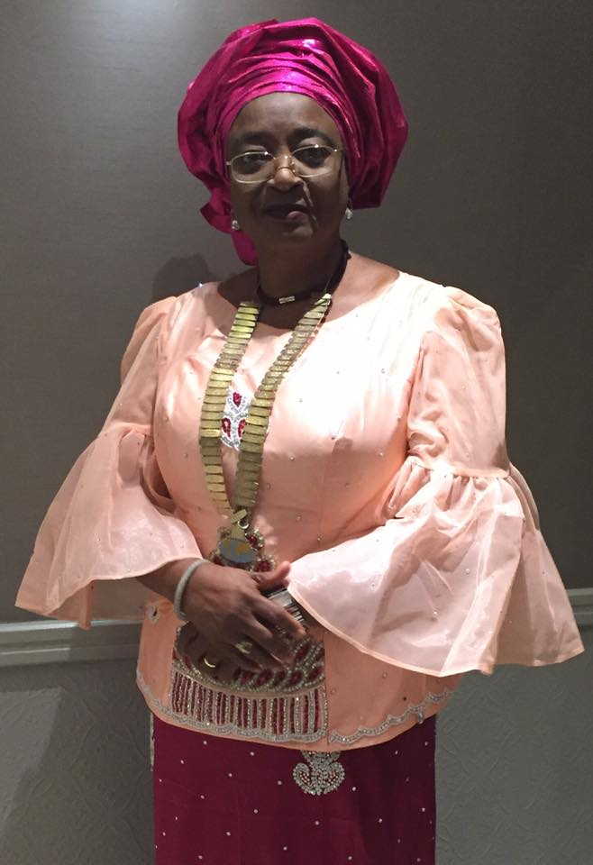

**KEYNOTE ADDRESS AT THE 4th WOMEN FOR AFRICA HOSTED BY DISTRICT 911 IN SAGAMU, OGUN STATE.**

**GIVEN BY OLUYEMISI ALATISE IIW PAST PRESIDENT**

Women for Africa 4th Edition Hosted by District 911

It gladdens my heart to note that the seminar has taken its sound footing in Nigeria. Women for Africa seminar took its root from Women for Europe. It’s first edition was in Finland in 2004 and several editions has taken place since then. It was introduced to disseminate information on relevant issues concerning women and children. It is meant to be another intellectual forum for educating members in order to educate the general public. Like a Teaching the Teacher system to create greater ripple of education amongst women and children. Apart from education it was almost meant to bring members together in a more formal forum devoid of bureaucratic system of our meeting to formulating policies to guide Inner Wheel activities.

Women for Europe has been hosted amongst many European countries as the name depicts. It started in Finland, and it has been hosted by Italy three times 2008, 2011, 2017, Greece 2019, Turkey 2018, Bulgaria 2014 to mention a few. They have handled topic like; Comparing way of Life and National Economic System, Feeding the Planet Energy for Life, Nutrition and Sustainability. The topic handled are highly technical. Their social system have handled the issues we see as problem.

WfA 1st edition was attended by delegates from Finland, Benin Republic, Togo and Cot ’de Voir. Papers were invited from foreign and local intellectual participants, were published in the various WfA booklets. For easy references.

Benefits: The first edition brought out the idea of Micro-Credit. It was meant to give empowerment to women who cannot get such facilities from Bank. The capital base for the Micro-Credit was a direct contribution from members through their registration fee and some few patriotic members that placed paid advertisement in our programmes. This has been the scenario for the subsequent editions.

Joint project for Solar Power was also another direct benefit of the first edition of WfA 1. But it did not work out as planned. The project was then solely supported by donations from individuals and District 914.

The subsequent seminars have increased the capital base of the Micro Credit. Past National Representative has also donated to it through the excess made from Rallies. The Capital base of the Micro Credit is growing at every opportunity to make it so. I have shared my Micro-Credit presentation with Spoleto Municipal City in Italy for possible implementation for Refugees. The Inner Wheel USA have also showed interest in the Micro Credit and promised to support financially. Inner Wheel Club of Tapiola have also supported that the Micro-Credit Schemes on two occasion with good donations.

The dream of Women for Africa is to make it go around the continent. To encourage other African countries to introduce it for the benefit of their community. Attempt has been made with Ugandans, hopefully it will materialize someday. Togo and Benin are planning to have theirs once their National Representative become functional and strong.

Women for Europe has transformed the Europeans to connect and have stronger voice. It is my dream that Africa Inner Wheel Clubs will achieve this someday. I have personally made attempt to bring Africa together, by contacting various countries that have Inner Wheel presence. But was greeted by many stumbling blocks. From language, to culture, to the colonial mentality that had divided Africa into small pieces. African countries are not opening their doors to each other, for fear of domination. The ones that has opened are plagued with xenophobia and deportation of each other’s nationals. There is so much mistrust amongst Africans that coming together as one will be very difficult. Egypt does not regard itself as African, Morocco prefers to align with France. Kenyan are not interested to be part. South Africa did not even respond. Language has divided us in West Africa. Central African Republic and Cameroun prefers to align with France.

The various educative tropically topic relevant to our society in the past editions are

Violence Against Women, Peace Education, Mother’s Word, Inclusion of Physically Challenged in Education.

Network for Renewable Energy for Africa,

Create Awareness on common Female Medical Disease and Reduce Mortality from them (Cervical Cancer and Fibroid) The Health Aspect – Focusing of VVF.

Micro Credit Empowerment – Women Leading the Way

Flooding Prevention and Control – Role of Women in Environmental Protection – Women in the Green Economy

Women and Inheritance – What does the Law says, Female Genital Mutilation – Circumcision and Cutting, National Health Insurance Scheme – Effect in Women’s Health, Information Technology in Schools

Security – Self Defense, Domestic Violence, Breast Cancer, Challenges – Future of Nigerian Girl Child, Motherhood and Working Mother

Feminists Ethics, Youth Practices and Family Ethics – Generation Gap or Intelligence, Terrorisms and Terrorist Acts, Child Trafficking in Benin, West Africa.

It may interest you to note that I knew nothing about Female Genital Mutilation, until a very educative lecture was presented by Prof. Modupe Onadeko at the WfA 2nd Edition in 2014. It was never practiced within my tribe. I never understood what it was all about. The presentation brought out the imminent danger of the abuse that has been in practice for generations and has given permanent scar on victims. It is ironic to note that adolescent girls who were not circumcised, submitted themselves to this abuse on request of intending suitors. It became a denominator to determine bride price of girls. I spoke to many victims and got more interested in this very harmful practice. It was the main topic at Conference I attended representing International Inner Wheel in Committee on the Status of Women at the United Nations in New York 2016. This gave me the inspiration to ask for papers about Female Privileges and Challenges – Cradle to Old Age from various countries around the world. The book I titled “The Coffee Table Book” was part of my travels as International Inner Wheel President 2016/17 and has been in wide circulation amongst Inner Wheel World. The practise is not peculiar for African alone, it is practise in some small villages in India. It has been exported by migrant to Europe. Protection of Human Right did not allow it to be widely accepted in United State of America.

The 4th of Edition is involving the general public. We have educated various Inner Wheel members from the three Districts. It is time we extend our learning to the benefit of the public. Hence the inclusion of the public this time around. In conclusion, I want to appeal to Inner Wheel District hosting the Seminar to encourage full participation of members of their District, because of distance within other Districts. Hosting District should primarily rely on local participation and support from the other Districts. The Capital base of the Micro Credit should be increase from time to time, because of devaluation and depreciation in currency, but should not be the main objective. We must remain focus on the intellectual education of ourselves in order to improve our life and pass the knowledge to other women. Once again you all most heartily welcome to enjoy and get educated on various topics to be handled.

Dear Members. I have gotten to peak of service in International Inner Wheel. The ball is now in the court of every one of us. I brought out Micro Credit Scheme, from the first edition, that has benefitted many indigent women and the Capital base is increasing through the direct contribution of members, while we are also learning from the learned. Renewable Energy through Solar Power Project at Idembia Health Centre in Abakaliki also came out from the First edition of WfA. I learnt more about Campaign against Female Genital Mutilation, through the lecture given by Prof. Onadeko, which I took to over 28 countries with the distribution of the Coffee Table Book that has articles contribution of members from around the Inner Wheel world. You will agree with me that I have paid my dues. I shall be glad to have younger members taking up the baton and fly the flag of Inner Wheel Nigeria to a much higher level. Let us make use of the points in the papers presented and explore possibilities of enriching ourselves to the benefit of other women around us and make the world a better place for women and girls. Thank you very much for your attention.

Oluyemisi Alatise

IIW Past President (2016/2017)

​

**Community Outreach**

**DRUG ABUSE AND MISUSE – A PRESENTATION BY MRS. OLUBOLA ODELEYE AT AKARIGBO’S PALACE ON 31ST OCTOBER, 2019 AT THE COMMUNITY OUTREACH OF INNER WHEEL NIGERIA TO WOMEN IN SAGAMU, OGUN STATE**

**Introduction.** Medical treatment in most cases is not complete without the patient taking drugs. The WHO describes rational use of drugs as a situation that requires that "patients receive medications appropriate to their clinical needs, in doses that meet their own individual requirements, for an adequate period of time, and at the lowest cost to them and their community". Rational use of drugs thus requires that an individual who needs medical care

1. Visits a medical doctor who
2. Prescribes medications appropriate to the individual’s clinical diagnosis
3. Takes the prescription to a pharmacist who dispenses the medications and counsels the individual on how to take the medications and for how long
4. The individual takes the medication as prescribed and dispensed.

Unfortunately, the above is hardly the case. Rather drugs are often used irrationally (misused/abused) and constitutes a major problem all over world.

There is often a lot of confusion between the definitions and meanings of the words abuse and misuse with respect to drugs and prohibited substances and are often used interchangeably.

**Misuse** is the improper use of either non-prescribed or prescribed medications. This is applicable in situations wherein the medication is taken for therapeutic purposes only and not for ecstasy, pleasure and euphoria.

Misuse of drugs include the following common practices

* Taking a dose at the wrong time or as needed instead of as prescribed
* Forgetting to take a dose
* Stopping a medication too soon
* Accepting prescription medication from a friend
* Taking drugs for reasons other than what they were prescribed for
* Taking in more than the prescribed amount of medicine e.g. if a person is not able to fall asleep after taking a single sleeping pill, he or she may take another pill an hour later or taking a combination of analgesics for quick relief
* Using too many medicines at a time ("poly-pharmacy")
* Over-use of injections when oral formulations would be more appropriate

**Abuse**, on the other hand, is a term that connotes the repetitive and willful use of drugs for another reason aside from its original or prescribed intention or use. It is using medicine or substance in a way other than its socially sanctioned purpose.

People who abuse drugs typically do not have a prescription for what they are taking. Not only do they use it in a way other than it is prescribed, but they also use it to experience the feelings associated with the drug. Euphoria, relaxation, the general feeling of ‘getting high’ is always associated with drug abuse. The abuse of drugs in the opiate and benzodiazepine families frequently leads to unavoidable side effects, including dependency and addiction.

“Signs of Drug Abuse”

* Using a drug to ‘get high’ e.g. Cocaine and others in its group (opioids) anesthetics/pain killers, alcohol, etc.
* Using without a prescription i.e. self-medication
* Exceeding a recommended dose
* Chronic or repeated abuse
* Developed tolerance

Thus, the difference between misuse and abuse is clearly on the difference of intention. The only problem is that one cannot readily tell that a person is misusing or abusing drugs by simply looking at him or her. However, one can say that substance abuse and misuse have already been reached if the user is already displaying some significant psychological, social and physical limitations or impairments.

**DANGERS OF DRUG MISUSE/ABUSE**

**Treatment failure** – can occur with taking a dose at the wrong time, forgetting to take a dose and stopping a medication too soon (for prescribed drugs).

Often, an individual buys the drugs himself/herself and may not take it appropriately. It can also occur with concomitant use of orthodox and herbal medications.

**Adverse/Side effects** – this is an unpleasant reaction to medications. It can occur with any drug but it is easier to detect and manage if the drugs are prescribed. The fact that one has been taking a drug for a long time does not preclude adverse reaction. ADR can be fatal.

**Resistance –** A medication that has been working well stops producing effect. This is common with antibiotics and it is a direct result of antibiotic misuse/abuse/overuse, that is, using an antibiotic when it is not an appropriate treatment or using more or less than is required.

**Addiction/Tolerance –** comes with repeated use of certain drugs or substances e.g., sedatives and tranquilizers, with repeated use, the individual is unable to sleep without it. The individual develops uncontrollable craving for the drug/substance. With time, higher and higher dose is required to get the same effect.

**Damage to internal organs** – this can occur as a result of overdose of medication, habitual use of drugs and indiscriminate use of herbal and orthodox medication, etc.

**Drug interactions** – unguided use of medications can lead to drug-drug, drug-food or drug-herb interactions. This can lead to therapeutic failure or even toxicity.

Summary

1. Drug misuse is the improper use of medications for purely therapeutic gains but does not include the improper use of drugs taken for pleasure and the like.

2. Drug abuse is a more repetitive and willful habit of taking drugs for the purpose of pleasure, ecstasy and euphoria but does not include the repeated use of drugs for therapeutic purposes.

**Conclusion –** Avoid indiscriminate use of drugs. Consult professionals.

REFERENCES

Brahma D., Marak M. and Wahlang J. (2012). Rational Use Of Drugs and Irrational Drug Combinations. *The Internet Journal of Pharmacology*, vol.10, No1

Medline Plus. Prescription Drug Misuse. Medlineplus.gov

National Institute on Drug Abuse (2018). Misuse of Prescription Drugs. drugabuse.gov

# WHO (2012). The Pursuit of Responsible Use of Medicines: Sharing and Learning from Country Experiences. WHO/EMP/MAR/2012.3

COMMUNITY OUTREACH CONTD

*DOMESTIC VIOLENCE:*  ***A PRESENTATION BY MRS. FOLAWE APANISILE AT AKARIGBO’S PALACE ON 31ST OCTOBER, 2019 AT THE COMMUNITY OUTREACH OF INNER WHEEL NIGERIA TO WOMEN IN SAGAMU, OGUN STATE***

Domestic violence can be defined as a pattern of behavior in any relationship that is used to gain or maintain power and control over an intimate partner. Abuse can be physical, sexual, emotional, economic or psychological actions or threats of actions that influence another person. This includes any behaviors that frighten, intimidate, terrorize, manipulate, hurt, humiliate, blame, injure or wound someone. Domestic violence can happen to anyone of any race, age, sexual orientation, religion or gender. It can happen to couples who are married, living together or who are dating.

Domestic violence affects people of all socioeconomic backgrounds and education levels. The management of domestic violence essentially requires combined effort of law enforcement, social welfare and health care services. Although efforts have been made in this direction, the attended cases represent just the tip of the iceberg, as majority of the cases are not reported due to social pressures from family members or social stigma of defamation. Real change in these cases can only be brought about by changing the mindset of society through education and better law enforcement.

Domestic violence is a pattern of assault and coercive behaviour including physical, sexual and psychological attacks, by a person against his/her own intimate partner. Women are more frequently the victims.

Results of studies about domestic violence show that children who are exposed to violence in their homes suffer short and long-term consequences. These children are at greater risk for being victims of child abuse, behavioral and psychological problems, have increased learning difficulties and more limited social skills, are at greater risk for depression or severe anxiety, and are at greater risk for exhibiting violent, risky, or delinquent behavior.

These children are also more likely to continue the cycle of domestic violence into adulthood. This paper discusses the definition and global scope of domestic violence and examines the factors that increase a woman’s risk for being a victim of domestic violence.

Types of domestic violence

1. Physical
2. Emotional
3. Economical
4. Sexual

Causes of domestic violence

1. Mental illness
2. Social stress
3. Physchological
4. Marital conflict
5. Jealousy

Management:

The response to domestic violence is typically a combined effort between law enforcement, social services, and health care.

Domestic violence historically has been viewed as a private family matter that need not involve the government or criminal justice.

Police officers were often reluctant to intervene by making an arrest, and often chose instead to simply counsel the couple and/or ask one of the parties to leave the residence for a period of time. The courts were reluctant to impose any significant sanctions on those convicted of domestic violence, largely because it was viewed as a misdemeanor offense.

1. Medical Response
2. Law enforcement
3. Counselling for offenders
4. Counselling for the victims

Conclusion: Despite efforts made by various sections of society and the Government to curb the menace of domestic violence against women, there is a rise in domestic violence.

This can be curbed by:

* Educating women about her rights.
* Community screening for domestic violence.
* Providing adequate assistance to the victim.
* By offering safe shelters, crisis intervention,
* advocacy, and education and prevention programs. Provision of strict laws and punishment for offence of domestic violence.

To conclude it is therefore necessary that every strata of society must contribute to ensure a violence free life for every woman.

NATIONAL GOVERNING BODY OF

INTERNATIONAL INNERWHEEL IN NIGERIA.

“PROTOCOL, ETIQUETTE AND HOSTING IN INNERWHEEL.” Presented by PNS FUNMI OGUNSI.

@

THE 4TH EDITION OF WOMEN FOR AFRICA CONFERENCE, 1ST NOVEMBER, 2019.

PROTOCOLS:

The National Representative and Chairman of National Governing Board,

Present Members of the National Governing Body,

The Past International Inner Wheel President,

Past Board Members and Board Directors,

Past National Representatives,

|  |  |
| --- | --- |
| Past District Chairmen,  District Chairmen,  Districts’ Officers,  Past Club Presidents,  Club Presidents, | Distinguished Guests,  Beautiful Sisters in Inner wheel, Ladies and gentlemen. |

It gives me great pleasure to stand before this august gathering to celebrate the 4th edition of WOMEN FOR AFRICA. I am proud of our organization for constantly seeking to update members for personal growth, as well as invest in the growth and development of others. I pray we shall all benefit immensely as we go through another educative and enlightening edition of this Workshop.

The topic for discussion is: *“Protocol, Etiquette and Hosting in Inner Wheel”. The word Protocol is part and parcel of our everyday discuss within our organization and I can conveniently, say that my first conscious application of the word started from my association with Rotary. However, today we are looking at this word with its twin, ETIQUETTE, and both in relation to HOSTING in Inner Wheel.*

*In discussing Protocol, Etiquette and Hosting in Inner Wheel* we shall be examining our attitudes, values, ethics, what we stand for as individuals and how the interplay of these qualities affect the effectiveness and efficiency of our organization’s programs and activities. That is, we want to be able to look inwards as individuals and as a group to assess ourselves against certain parameters, to evaluate what we do well and what we can do better still. Thus, I hope as Addison says, we shall this day, “be able to enliven morality with wit and temper wit with morality’’.

Our organization, as an international body operates within specific frameworks and standards. It is governed by protocols of rules and regulations, constitutions, conventions, expectations, customs and byelaws that we as members must adhere to, in order to achieve its aims and objectives as well as operate at the expected and desired levels of competencies. What then have been our experiences thus far? Do we meet those standards and competencies in ALL that we deal?

How have our outings been: our meetings, both clubs’ and district functions: like the National Rallies, Installation Ceremonies, Chairmen’s Visits and Presentations? How have we faired? We have garnered quite a number of years organizing these events, have we gotten them top notch? What have we been doing right and which are those areas or aspects we could have done better? Will a better appreciation of Protocols and Etiquette be beneficial to us all in achieving more successful and hitch free hosting? We shall make references to some of these events in addressing this topic.

**WHAT IS PROTOCOL?** The Longman’s Dictionary of Contemporary English defines

Protocol as “a system of rules about the correct ways to behave on an official occasion”. The right order of doing things. This means there are acceptable ways to execute programs and to behave at different gatherings and conversely, there are also unacceptable ways! For us, we have taken PROTOCOL to refer singularly to who takes precedence over who at our gatherings. That is protocol all right yet, it goes beyond that! Protocol is also defined as the combination of good manners which allow for effective communication. As all our gatherings are official occasions and business meetings, it behooves on us therefore, to observe rules/ protocols to guide our operations so that we can achieve the desired result. Adherence to these basic rules always allows for meaningful communication and improved output which we all desire.

Observing protocols in our meetings is closely related to etiquette. Whilst protocol is the correct procedure and processes to abide with, etiquette is the correct interpersonal relationships that make the procedures meaningful. (My earliest appreciation of etiquette as good manners and proper behavior derived from my late, non-literate paternal grandmother, who would berate us at every misbehavior as, “wen ne etiquette!” Etiquette is therefore, the body of manners and forms prescribed by customs, usage or authority. It is accepted as correct behavior when dealing with one another.

The principles of Protocols and Etiquette encompass courtesy and respect; good manners and gracious disposition; comportment and truthfulness; self-control and kindness towards others. These are the acts that are indicative of good judgement in social, professional and other situations. Etiquette is showing respect for yourself and everyone else in your little corner of the planet, being polite and thoughtful not only to those we are familiar with but to all, irrespective of their stations in life.

It is generally accepted that the minimum modicum of good manners is the ability to say, *please, thank you, excuse me* and *sorry* as appropriate and relating to others with a SMILE! This is being polite. Simple courteous acts of holding the door for the person behind you; looking at the person talking to you; learning peoples’ names are some of the correct expectations for inter-personal behavior.

Most especially today, we want to relate these two values to HOSTING of our events and assess how these affect the quality and standards of our gatherings. On the one hand we must give kudos to ourselves for the levels of the preparations we put into our programs. When asked to function in various committees, we go to great extents putting in time, energy, manpower and great financial resources to organize grand events which ought to end top notch. We also dress gaily and elegantly and befittingly to attend in our numbers. What then are the fault lines? What sometimes mar these efforts and take away from our hosting?

Let us look at Keeping Time and Punctuality. What are the expectations in this wise? We want to appreciate all those that are always punctual to our gatherings. Thank you and please keep it up! Those who do not keep time force those who do to wait for them! The rule of etiquette says, ‘’Please do not make people wait for you’’. Show others that you value their time. How then does this affect our hosting? The late comers most often will not enter quietly and sit down, they will start to greet and gist; thereby disrupting the proceedings. Sometimes, organizers interrupt proceedings to introduce late comers with singing and aplomb. Do we have examples of such behavior at our international fora?

Please do not get me wrong, it is correct etiquette to greet everyone when we enter a room and if per chance, we are shaking hands, we should shake firmly and smile; not only at those we know nor at only those from our District! Do greet please, but when we come late and the business session is on, we should kindly come in quietly, take our seats and acknowledge people around us, with a bow, a nod, a gesture of acknowledgement that would not disrupt the meeting. Acting otherwise is breech of protocol!

This leads me to our all time-consuming photograph sessions! How has the management of our photography sessions affected the taking off and continuation of our programs? Can we handle this better? I want to humbly suggest that henceforth, we should put photography sessions or Red-Carpet time on our programs. That is, we should allocate time officially for this before every session and thereafter it becomes a sanctionable infringement of our protocols to take photographs during business sessions, except the official ones for the event. And whilst at it,

Sisters, are we aware that we should ask before posting people’s pictures on social media? In this day of social media malaise, we may just have to ask before posting!

The smart phone is one of the most cherished possessions of this day and age, isn’t it? Yet everyone knows that it is not acceptable in decent society to allow the phone to cause disruption at an event. It is good judgement to silence the ringer at every gathering formal or informal. If a phone must be answered, please step out as a sign of regard for others. It is not acceptable to raise our voices above the noise of the gathering. No one needs to be privy to our conversations, please. It is inappropriate to answer calls while someone is attending to us, then apologies after. Please, let us use our smart phones in smarter ways!!!

Not keeping the noise down at an event is one of the greatest breaches of etiquette, decorum and protocol and it is the greatest bane of our hosting. Most times we mar what would have been the most beautiful events or at the least remove from their classiness and beauty by not keeping our noises down. Always let us be mindful of this and most especially, when food is served! Why allow food serving disorganize our programs? There is a whole lot of protocols related to conduct at buffets and table etiquette. Who goes first and in what sequence should reflect protocol and etiquette? It will also be helpful if organizers communicate the arrangements and procedures for food serving at our events, more explicitly.

Let us endeavor to skip private conversations, especially controversial topics and gist during our business meetings as well as reduce side talks to the barest minimum. There is no way anyone will not be aware when there is noise so ‘‘we should of ourselves judge ourselves’’.

The most unpardonable of this breach is when the noise overrides the voice of a Guest Speaker. The Guest Speaker is invited to speak to us, to not listen is a faux pas. I sincerely hope that we shall take note of this for the future. Equally, should we note that protocol and etiquette demand that we do not leave before our guests. We invited them as well and just as we do not leave our visitors in the sitting room and go to bed, we should accord our guests the same dignity.

The rules of etiquette should also guide and moderate our reactions whenever there are short falls in our arrangements. We should accept corporate responsibilities for them and keep a united front, always. Let us be wary of unkind comments that give offence, generate resentments or cause embarrassment to others. Being gracious and kind is the hallmark of etiquette! However, it is GOOD PROTOCOL to come together to review and evaluate our performances after every outing/hosting. Whereby we look dispassionately into what we have done well, acknowledge those things we need to improve upon, and put actions in motion to correct such. When we review our activities in friendly and non-judgmental manners, we shall continue to learn and to excel. More members will gain confidence and enthusiasm in discharging their responsibilities and the fear of being “crucified” when things do not work out will be minimized. I hope this discourse today will be an impetus for us to start evaluating and upping the ante! My beautiful Inner Wheel Sisters let us begin to fix it and come out more protocol and etiquette savvy!

Once again, I want to appreciate the organizers for giving us all the opportunities to develop ourselves: for self, and for the benefits of our organization.

My lovely sisters, Protocol is the glue that holds everything together while correct etiquette allows precedence to be adhered to. Without etiquette, the custom of polite society would soon disappear and we would act less like people!

And we are people!

Thank you.

PNS Funmi Ogunsi.

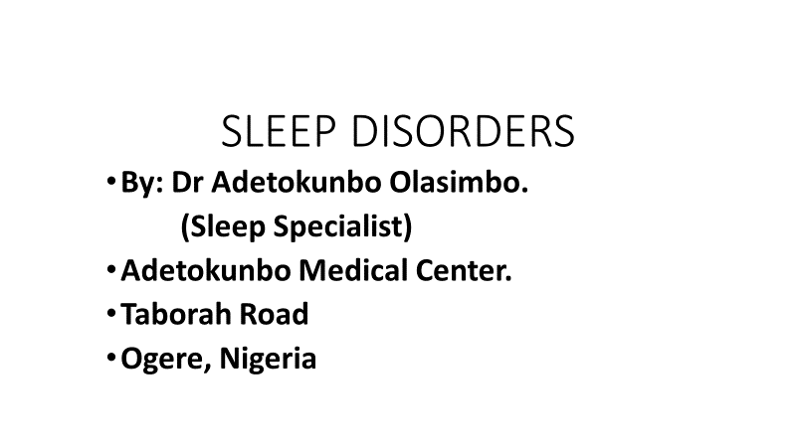

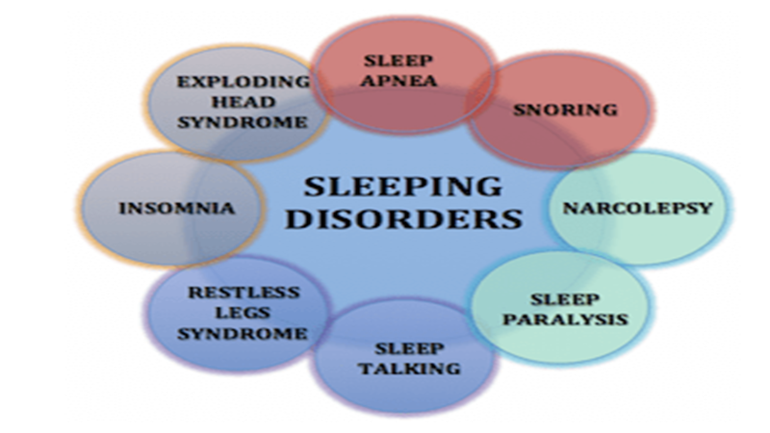

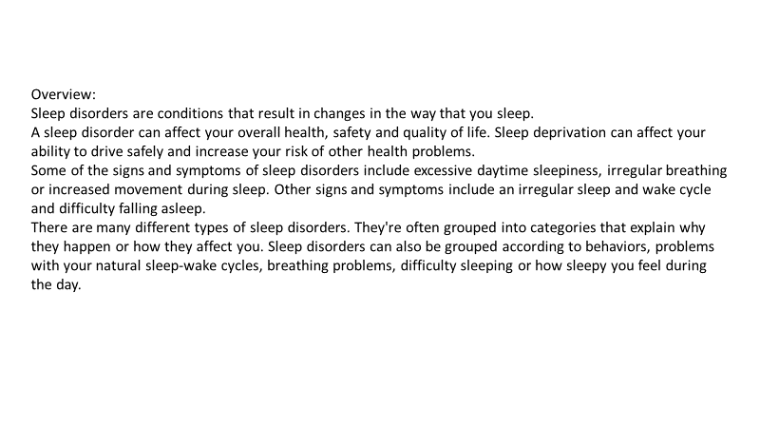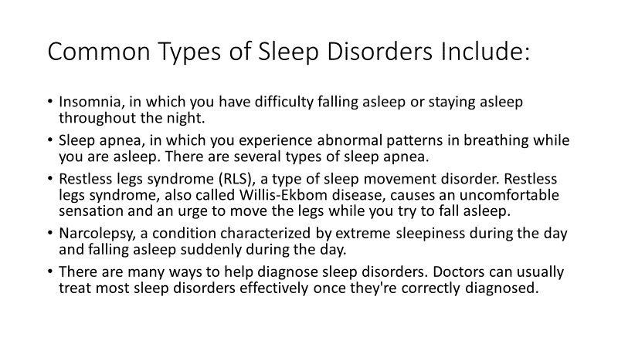

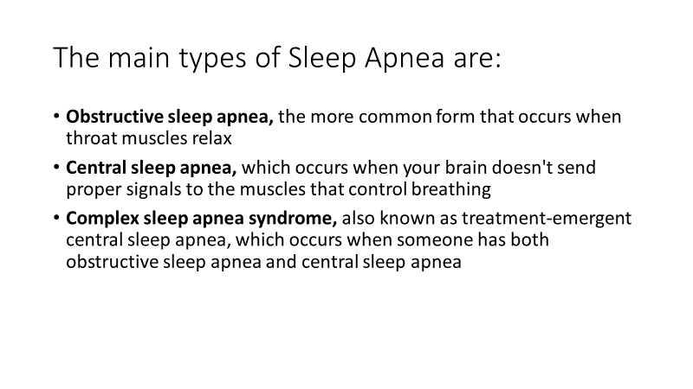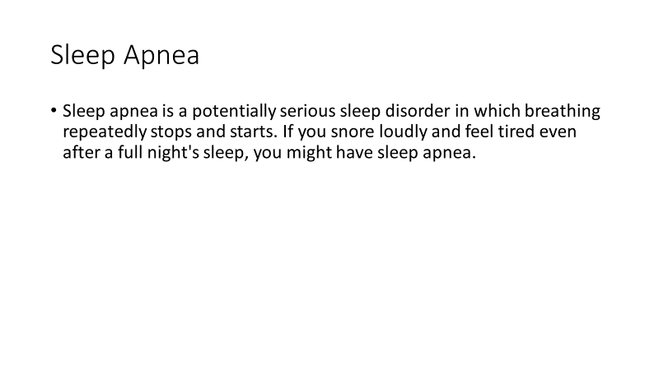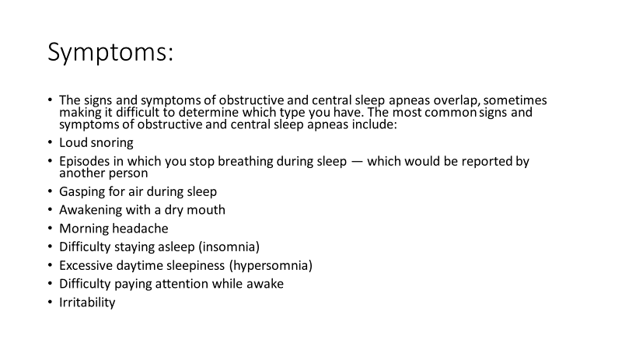 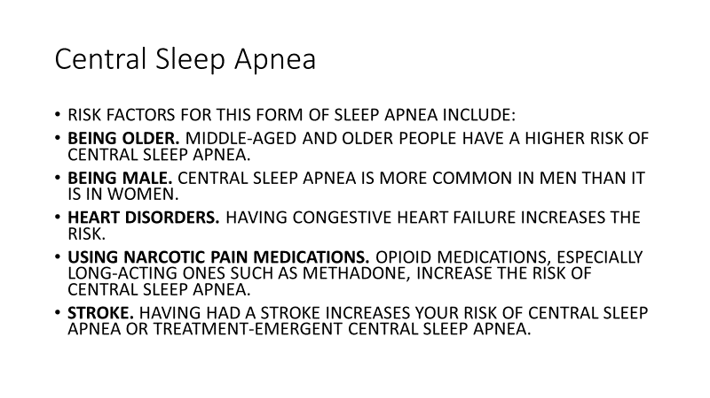

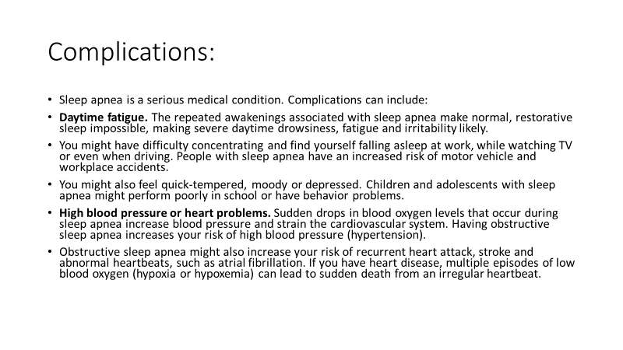

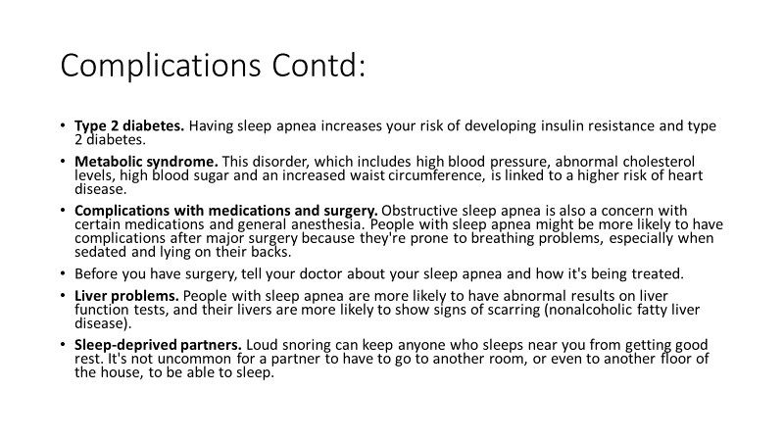

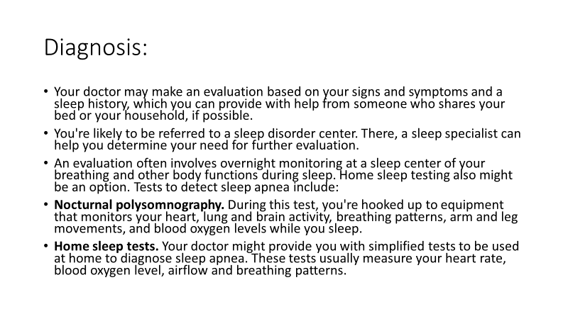

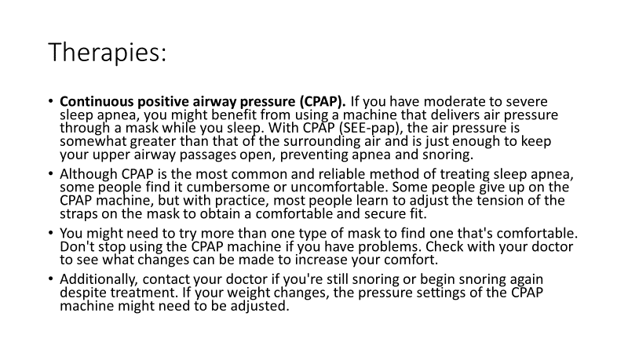

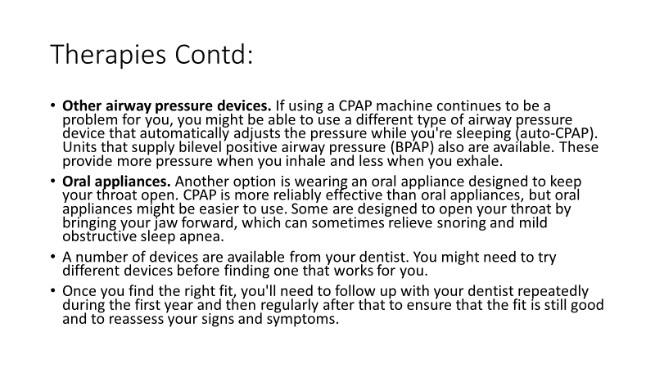

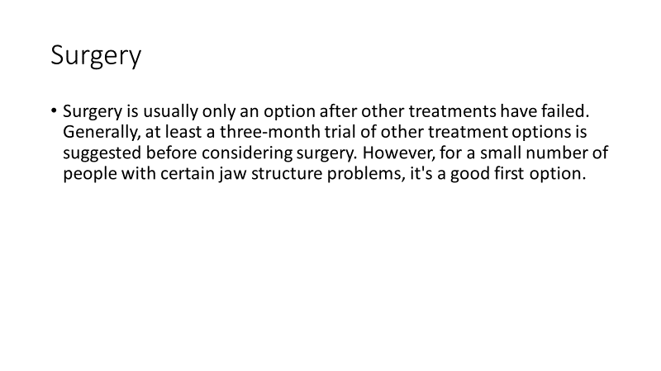

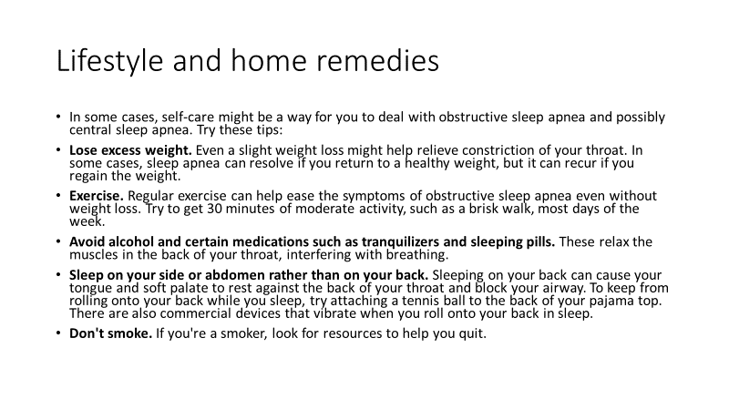

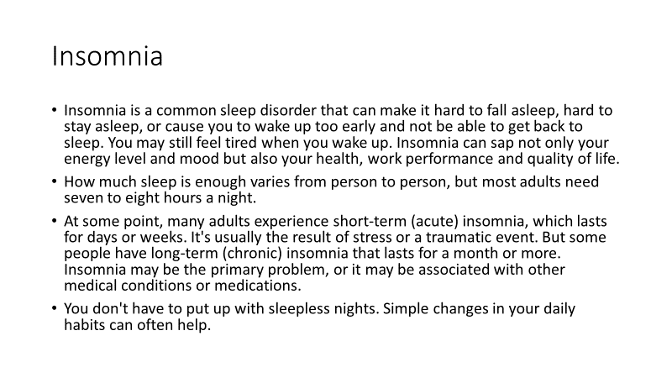

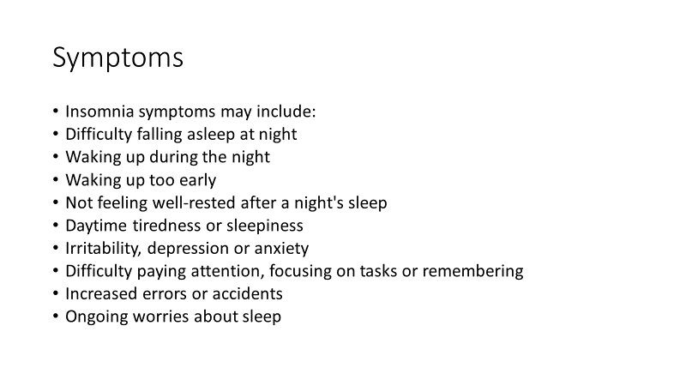

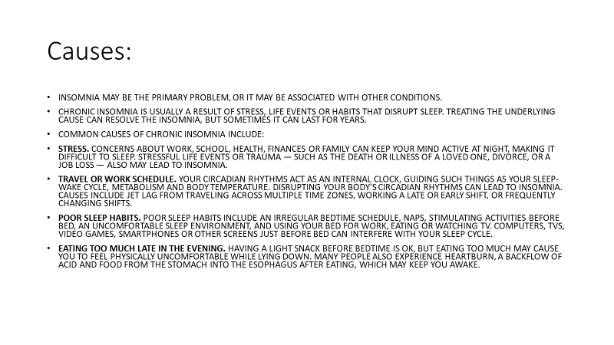

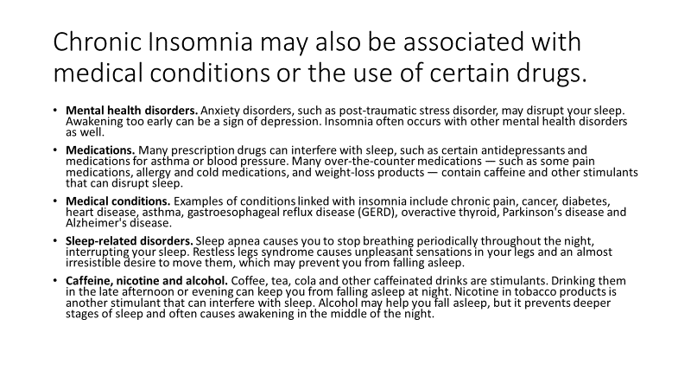

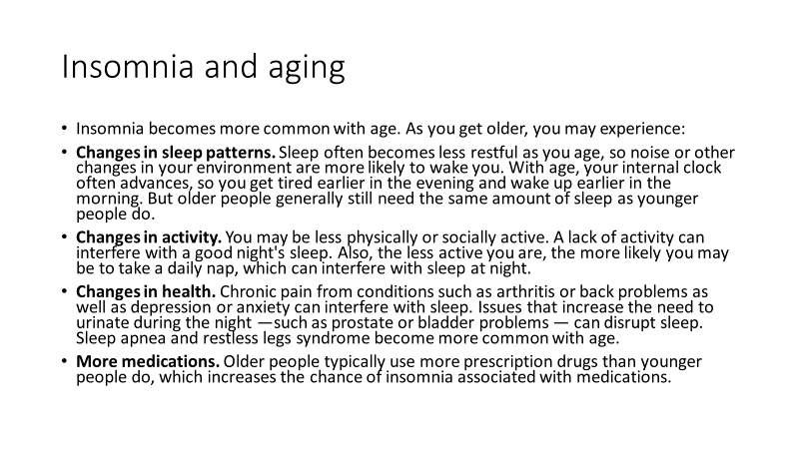

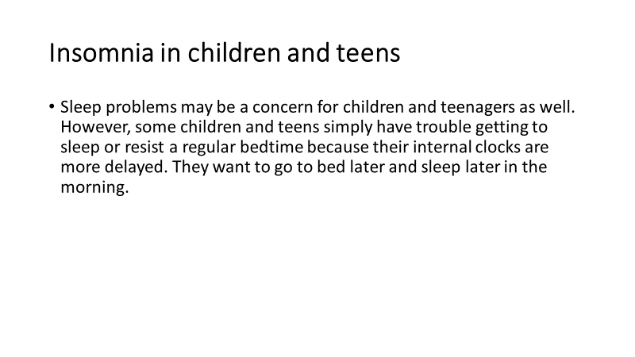

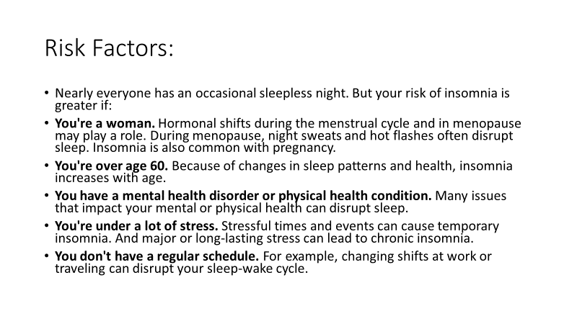

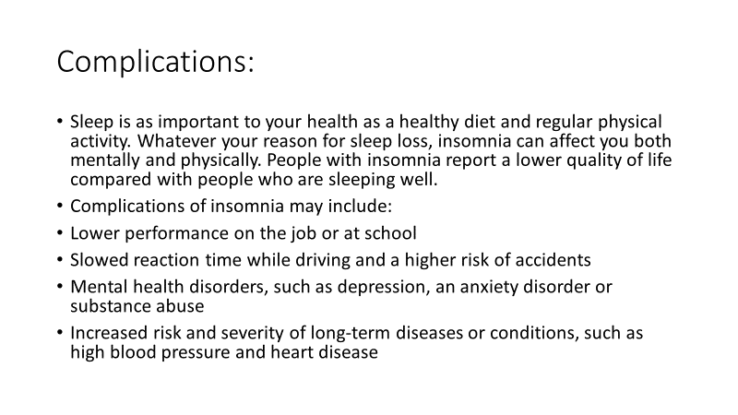

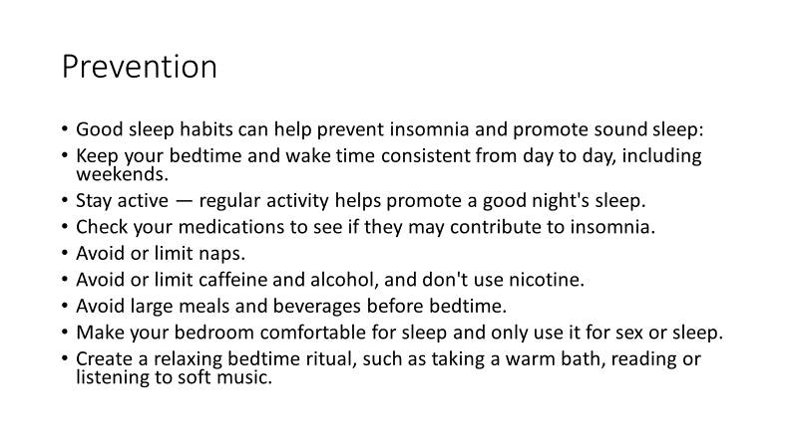

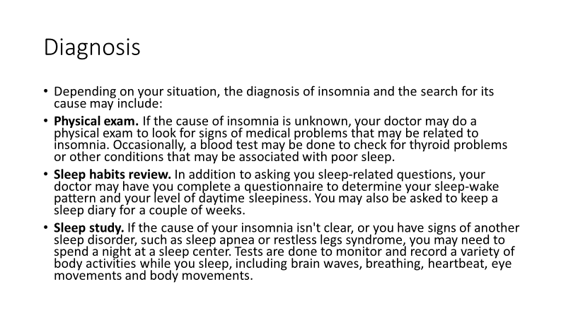

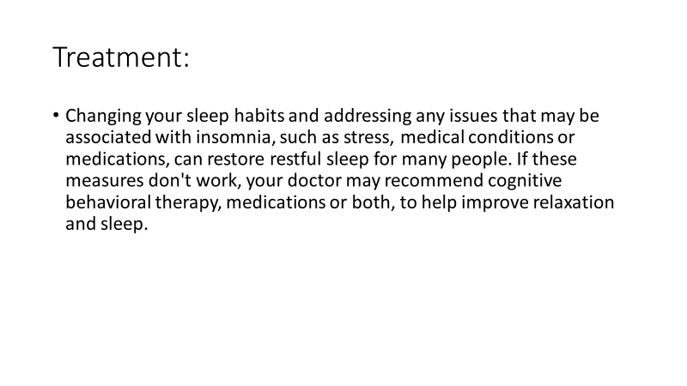

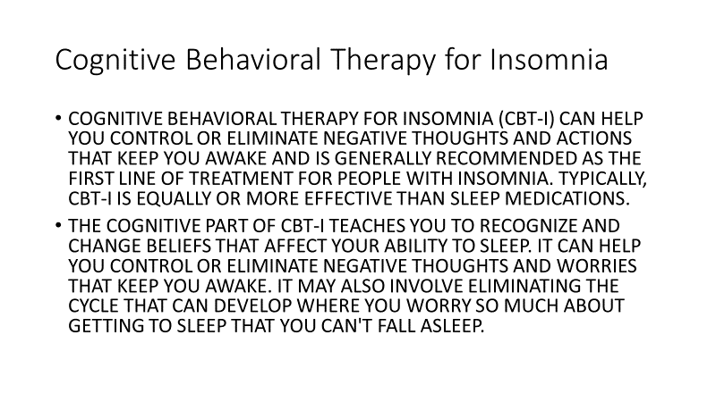

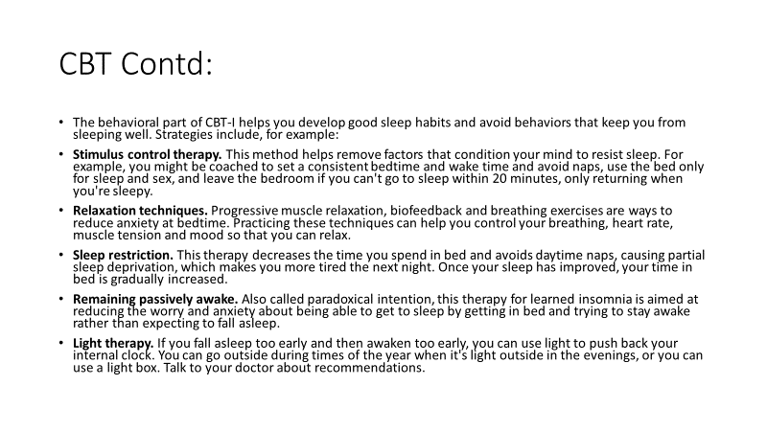

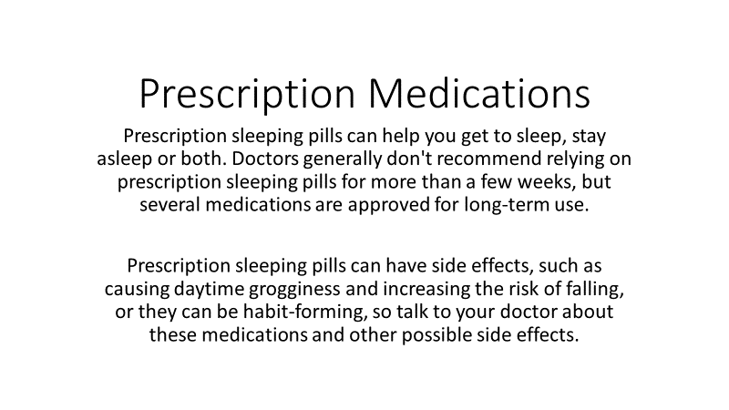

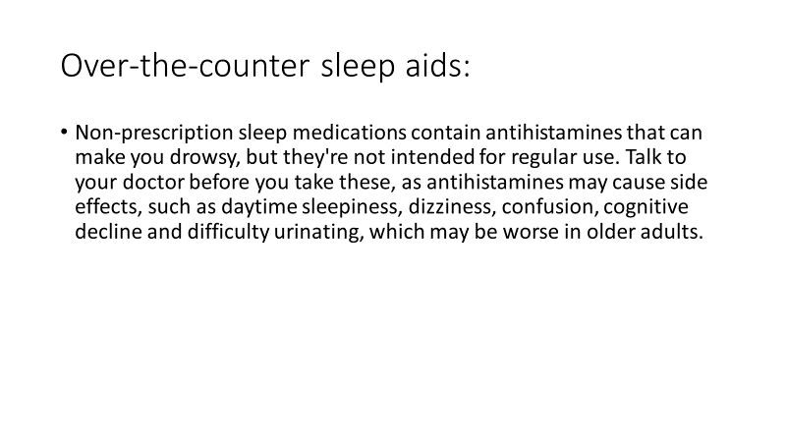

**CORE PAPER**

**AGONIES OF DOMESTIC VIOLENCE; VULNERABILITY AND DEFEENCE MECHANISM**

**BEING A PAPER PRESENTED AT THE 4TH CONFERENCE OF INTERNATIONAL INNER WHEEL IN NIGERIA TAGGED ‘WOMEN FOR AFRICA IN 21ST CENTURY HELD BETWEEN 31ST OCT-3RD OF NOV AT NANDAS HOTEL SAGAMU, OGUN STATE.**

**BY**

**DR. MRS ABIMBOLA OLUDIPE**

**HEAD OF DEPARTMENT, SCIENCE AND TECHNOLOGY, FACULTY OF EDUCATION, OLABISI ONABANJO UNIVERSITY, OGUN STATE, NIGERIA**

**INTRODUCTION.**

Domestic violence is violence or other abuse by one person against another within a sphere mainly homes and in relationship. Domestic violence may be physical, emotional, economic, stalking, harassment, sexual, verbal, neglect or aggressive behavior within the home, typically involving the violent abuse of a spouse or partner causing, pains, distress or injury. For violence to be ‘domestic’ it doesn’t have to occur within your home, only within a relationship (family or an intimate partner). It occurs when someone close to you has power and control over you this control or abuse can be expressed in different ways. Domestic violence occurs globally (Dahlberg and Krug, 2002, UNICEF, 2005). Families from all social, racial economic, educational and religious backgrounds experience domestic violence in different ways. Djaden & Thoennes (2002) reports that in the United States of America, each year women experience about 4.8 million intimate partner-related physical assaults and rapes while men are victims of about 2.9 million intimate partner related physical assaults. In parts of the third world generally and West Africa in particular, domestic violence is prevalent and reportedly justified and condoned in some cultures. For instance,56% of Indian women surveyed by an agency justified wife-beating on grounds like –bad cook, disrespectful to in-laws, producing more girls, leaving home without informing, among others (Basu and Pratishthan2002, IRIN 2007)

Common forms of violence against women in Nigeria are rape, acid attacks, molestation, wife battering and corporal punishment (Noah & Yusuf, 2000). In Nigeria, reports reveal “shockingly high” level of violence against women (Afrol News, 2007). Amnesty international (2007) reports that a third (and in some cases two-thirds) of women are believed to have been subjected to physical, sexual and psychological violence carried out primarily by husbands, partners and fathers while girls are often forced into early marriage and are at risk of punishment if they attempt to escape from their husbands. More pathetic is the revelation of gross under reporting and non- documentation of domestic violence due to cultural factors (Oyediran and Isugo, 2005, afrolnews, 2007).

**Prevalence Data on different forms of violence**

**against Women**.

* Lifetime physical and/or sexual intimate partner violence: 16%
* Physical and or/sexual intimate partner violence in the last 12 months: 11%
* Lifetime non-partner sexual violence 2%
* Child marriage 44%
* Female genital mutilation/cutting 18% (according to United Nations, 2016)

Who are most vulnerable to domestic violence? Vulnerability for abuse is a product of the complex interaction of individuals, interpersonal and societal/institutional factors. People most vulnerable are;

* Younger Age
* Less educated people
* Unemployed
* Pregnant women
* Childhood victimization
* Women with disability

Intimate partner abuse is not the same in every relationship some abuse are frequently violent from time to time to assert their power. The fear that a victim lives in will make it difficult for her (victims are most often female) but not always) to confide in friends or family, because the retaliation may result in more danger. Only the victim can stop the violence and there are services in our community that can help a victim find the courage to stop the harm being done. Intimate partnership victims and perpetrators of domestic violence come for all walks of life, they can be educated, practice religion, have well-paying job, be unemployed, use drugs and drink alcohol, be survivors of childhood abuse. Families from all social, racial, economics, educational and religious background experience domestic violence in different ways (Alhie, 2009). In some communities, and in most cultures, there are values and social norm that expects or permit men to be in control (particularly their family), this control creates an imbalance of power in the relationship. The messages we give to our children (and learn ourselves) about masculinity and femininity make us believe that men have a right to dominate over their partners, and can do whatever is necessary to get their partners to do what they want them to do or behave the way they believe they should behave.

**RECORD OF DOMESTIC VIOLENCE IN SOME COUNTIRES AND NIGERIA**

According to various national surveys, the percentage of women who were physically assaulted by an intimate partner varies substantially by country.

Barbdos (30%), Canada (29%), Egypt (34%). New Zealand (35%), Switzerland (21%) United State (33%), India around 70% women are victims of domestic violence (BBC News, Oct 26, 2006). Turkey 42% of women have suffered physical or sexual violence (The Economist May, 2011) and Nigeria, up two-thirds of women in certain communities in Lagos State, Nigeria say they are victims of domestic violence (Afrol News 2007). UNICEF 2001 in its study asserted that in Nigeria there had been reports of cases of husbands killing and maiming their wives in the media. The statistics presented by This Day (2011) newspaper are daunting. About 50% of women have been battered by their husbands. Shockingly, more educated women (65%) are in terrible situation as compared with their low-income counterparts (55%). In the study of Agbo&Choji (2014), in Abuja, Nigeria, a mother of one narrated her ordeal in the hands of her husband, who constantly hits and beats her whenever he is drunk, and she had lost two pregnancies as a result of his brutality (Fareo, 2015.).

Similarly, interviews carried out in Oyo State and other parts of Nigeria were equally similar. Incidence of domestic violence is high much of which is committed against females. CLEEN Foundation (2013) report shows that, 1 in every 3 respondents admitting to been a victim of domestic violence. The survey also found a nationwide increase in domestic violence in the past 3 years from 21% in 2011 to 30% in 2013. Domestic violence is widespread and shows no sign of lessening in Nigeria (CLEEN foundation (2013).

**Various forms of domestic violence against Women.**

**1. Physical abuse:** This is the use of physical force in a way that injures the victim or puts him/her at risk of being injured. It includes beating, kicking, knocking, punching, choking, confinement. Female genital mutilation is physical abuse. Physical abuse is one of the commonest forms of abuse. Obi & Ozumba (2007) found that83% of respondents in their study reported physical abuse.

**2. Sexual abuse:** This includes all forms of sexual assaults, harassment or exploitation. It involves forcing a person to participate in sexual activity, using a child for sexual purposes including child prostitution and pornography. Marital rape also comes under this.

**3. Neglect:** This includes failure to provide for dependents who may be adults or children, denying family members food, clothing, shelter, medical care, protection from harm or a sense of being loved and valued.

**4. Economic abuse:** This includes stealing from or defrauding a loved

one, withholding money for essential things like food and medical treatment, manipulating or exploiting family member for financial gain, preventing a loved one from working or controlling his/her choice of occupation.

**5. Spiritual Abuse:** This includes preventing a person from engaging in his/her spiritual or religious practices or using one’s religious belief to manipulate, dominate or control him/her.

**6. Emotional Abuse:** This includes threatening a person or his or her possession or harming a person’s sense of self-worth by putting him/her at risk of serious behavioral, cognitive, emotional or mental disorders. Shouting at a partner which was found to be the most common abuse by Obi and Ozunba (2007) is included. Also included in emotional abuse are name-calling, criticism, social isolation, Intimidating or exploitation to dominate, routinely making unreasonable demand, terrorizing a person verbally or physically and exposing a child to violence. Abuse may occur once, or it may occur repeatedly often in an escalating manner. A person may be subjected to more than one form of abuse.

**CAUSES OF DOMESTIC VIOLENCE AGAINST WOMEN**

1. Psychological; Psychological theories focus on personality traits and mental characteristics of the offender. Anger, lack self- control, lack of self-esteem, as well as perpetrators environment such as social structure, acceptance by friends may constitute to sudden burst of anger which can results into aggressive moods which can lead to wife battering.
2. Social stress; Violence is not always caused by stress but is one of the ways some respond to stress (Seltzer &Kalmus, 1988). Where there is paucity of fund for financial engagement aggression may be transferred which may result in battering.
3. Extreme jealousy; Many cases of domestic violence is predicated on jealousy most especially where wife is suspected of infidelity, and a times when a wife is economically viable than the husband.
4. Power & Control; Abusers doesn’t need an excuse to abuse. Because most abusers have low self- esteem the moment, they can’t handle a situation, they become unnecessarily bitter, hostile and difficult hence will recent any woman who doesn’t fall in line with their ideology.
5. Upbringing of a child; A child’s background determines to a large extent characters and values. A child brought in a peaceful atmosphere where there is love and kindness to girl child and ultimately womanhood will learn to value and respect women.

**Effect of Domestic violence against women**

1. Physical Effect: Bruises, broken bones, head injuries, laceration, internal bleeding, miscarriages, pre-term labour, death of fetus are some of the effect of domestic violence incidence that require attention and hospitalization (Jones 1997 and Berros 1991).
2. Physiological Effect: The most common of physiological effect of domestic violence is Post Traumatic Stress Disorder (PTSD). Which is characterized by flash back, intrusive images, exaggerated startle response, nightmare and avoidance of triggers that are associated with the abuse.
3. Financial Effect: Once victims leave their perpetrator, they come to realize the extent to which the abuse as taken their autonomy. This has been shown to be one of the greatest obstacles facing victims of the domestic violence and the strongest fact that can discourage them from leaving their perpetrators (Stop Violence against women 2010).
4. Long Term Effect: Domestic violence can trigger many different responses in victims, all of which are very relevant for a professional working with a victim.
5. Effect on Children: A child expose to domestic abuse during is upbringing will suffer in his development and physiological welfare (Dodd. 2009) which can lead to aggressiveness, anxiety, attitudinal problems and academic challenges (Sadeler, 1994). Additionally, in some cases the abuser will purposely abuse the mother in front of the child to cause a ripple effect, hunting two victims simultaneously. It has been found that children who witness mother-assault are more likely to exhibit symptoms of posttraumatic stress disorder (PTSD) (Lehman, 1995).

**10 WAYS OF PREVENTING DOMESTIC VIOLENCE**

1. **Know the sign,** Domestic violence can happen to anyone, white, black, young, old, rich, poor, educated, not educated. Sometimes violence begins early on in a relationship and other times it takes months or even years to appear. But there are some warning signs. Be wary of the following red flags an abuser may exhibit at any point in a relationship.

* Be jealous of your friends or time spent away from your partner
* Discouraging you from spending time away from your partner
* Embarrassing or shaming you
* Controlling all financial decisions
* Making you feel guilty for all the problems in the relationship
* Preventing you from working
* Intentionally damaging your property
* Threatening violence against you, or someone you love to gain compliance
* Pressuring you to have sex when you don’t want to
* Intimidating you physically especially with weapon

1. **Don’t ignore it;** Police officers hear the same thing from witnesses again and again- I heard/I saw/perceived domestic violence but didn’t want to get involved. If you hear your neighbors engaged in a violent situation, raise an alarm or call the police. It could save a life
2. **Lend an ear. If** someone ever confides in you, they are experiencing domestic violence, listen without judgment. Believe what they are telling you and ASK HOW YOU CAN HELP.
3. **Check in regularly**; If a loved one or friend is in danger, reach out regularly to ensure his or her safety.
4. **Be a resource**; Someone experiencing violence may not be able to research shelters, escape plans or set up necessities like bank accounts or cell phones while living with his or her abuser, offer to do the legwork to help ease stress and keep thins confidential.
5. **Get a word out**. Assist domestic organization in their efforts to raise awareness in your community. Or used your personal connections to start a grassroots campaign. Organize talks at your workplace, meeting, and church group
6. **Put your money where your mouth is;** Use your power as a consumer and refuse to support the culture perpetuated in music, movies, television, games and the media that glorifies violence, particularly against women
7. **Write it down;** Document every incident you witness and include the dates, time, location, injuries, and circumstances. This information could be very useful in later police reports and court cases, both criminal and civil.
8. **Be available;** If someone you know is thinking about leaving or is in fear the violence will escalate, be ready to help. Keep your phone with you and the ringer on, make sure you have gas in your car and discuss an escape plan or meeting place ahead of time.

**Be Prayerful;** Commit your relationship into the steady hands of God [www.domesticshelters.org/articles](http://www.domesticshelters.org/articles) 2019

**REFERENCES**

Afrol News (2007) Half f of Nigeria’s Women experience domestic violence

retrieved May 22, from http/www/afro.com/article/16471

Agbo & Choji (2014): Domestic violence against women. Any end in sight? From

leadership news/382501

Aihie Ose N (2009) Prevalence of domestic’s violence of Nigeria. Edo Journal of

Journal of counseling vol. 12, No. 1 May 2009.

Alhie Ose .N (2009) Prevalence of Domestic Violence in Nigeria: Implicate for

Counseling. Edo Journal of Counseling Vol. 2 (N) May. 2009

BBC New Education (2003) Violence at home his children’s IQ. Retrieved May

2008 from http. New.bbc co. u.k/hileducation/298.1312.stm

Berros D.G (1991). Domestic Violence: Risk factors and outcome. Wester

Journal of Medicine. 17(2), 133-143

Dodd L.W. (2009). The Therapeutic group work with young children and

mother who have experienced domestics abuse. Education psychology in

Practice. 25 (21)

Dahlberg L.L & Krug E.G. (2002): Violence- a global public health problem. In

King E Dehlberg et.al (Eds.) World report on violence and Health Geneva Switzerland. WHO156

Fareo D. Oluremi (2015). Domestic Violence against women in Nigeria.

European Journal of Psychological Research Vo1.2 (1), 2015 ISSN 2057-4794.

IRIN (News) (2007) Female genital mutilation a vote winner in Sierra Leone 17th

March. http/www/afrol.com/printable article/15927

Jones 1997, R.H (1997). The American College o Obstetrician and Gynecologist

a decade of violence against women. International Journal of Gynecology and Obstetrics. 58 (1), 43-50

Nicholas Crime Vichmet Survey (2013). Nigeria Society. Interpoint Journal

2000

Noah, Yusuf (2000); ‘Incidence’ and dimension of violence against woman in

Obi S.N & Ozumba B.C (2017) Factors associated with domestic violence in

South East Nigeria. Journal of domestic and gynecology 27(1)75-78

Seltzer & Kalmus (1998). Socialization and Stress explanation for spouse

abuse, social force. 67(2), 473-491

The New York Times (2013); Entrenched Epidemic: Wife-beaching is Africa.

retrieved 2013-20-04

This Day (2011-Sept 20) Domestic violence. When law fails to protect

http/www./this dayline.com

Sadeler .C, (1994). An ounce of prevention: The life story and perception of

men who sexually offence against children. (Unpublished M.A. Thesis) Wilfred Laurier University/http/Scholars.wlu.ca.etd/634

Stop Violence against women (2010). Retrieved on April 24, 2010 from

http//www.stopvaw.org/dometics/violence1974.

UNICEF (2001). Children Women Right in Nigeria. A wake-up cell assessment

and analysis edited by Hodge. Abuja National Population Commission and UNICEF.

UNICEF (2005), Violence a Home (Archive) voices of / roy / discussion /

archive /index

Wikipedia (2012) Domestic Violence Retrieved in Def 2019 from

httplen.wikipedia.org/wiki/Domestic. Violence

Domestic violence can be defined as a pattern of behavior in any relationship that is used to gain or maintain power and control over an intimate partner. Abuse can be physical, sexual, emotional, economic or psychological actions or threats of actions that influence another person. This includes any behaviors that frighten, intimidate, terrorize, manipulate, hurt, humiliate, blame, injure or wound someone. Domestic violence can happen to anyone of any race, age, sexual orientation, religion or gender. It can happen to couples who are married, living together or who are dating.

Domestic violence affects people of all socioeconomic backgrounds and education levels. The management of domestic violence essentially requires combined effort of law enforcement, social welfare and health care services. Although efforts have been made in this direction, the attended cases represent just the tip of the iceberg, as majority of the cases are not reported due to social pressures from family members or social stigma of defamation. Real change in these cases can only be brought about by changing the mindset of society through education and better law enforcement.

Domestic violence is a pattern of assault and coercive behaviour including physical, sexual and psychological attacks, by a person against his/her own intimate partner. Women are more frequently the victims.

Results of studies about domestic violence show that children who are exposed to violence in their homes suffer short and long-term consequences. These children are at greater risk for being victims of child abuse, behavioral and psychological problems, have increased learning difficulties and more limited social skills, are at greater risk for depression or severe anxiety, and are at greater risk for exhibiting violent, risky, or delinquent behavior.

These children are also more likely to continue the cycle of domestic violence into adulthood. This paper discusses the definition and global scope of domestic violence and examines the factors that increase a woman’s risk for being a victim of domestic violence.

Types of domestic violence

1. Physical
2. Emotional
3. Economical
4. Sexual

Causes of domestic violence

1. Mental illness
2. Social stress
3. Psychological
4. Marital conflict
5. Jealousy

Management:

The response to domestic violence is typically a combined effort between law enforcement, social services, and health care.

Domestic violence historically has been viewed as a private family matter that need not involve the government or criminal justice.

Police officers were often reluctant to intervene by making an arrest, and often chose instead to simply counsel the couple and/or ask one of the parties to leave the residence for a period of time. The courts were reluctant to impose any significant sanctions on those convicted of domestic violence, largely because it was viewed as a misdemeanor offense.

1. Medical Response
2. Law enforcement
3. Counselling for offenders
4. Counselling for the victims

Conclusion: Despite efforts made by various sections of society and the Government to curb the menace of domestic violence against women, there is a rise in domestic violence.

This can be curbed by:

* Educating women about her rights.
* Community screening for domestic violence.
* Providing adequate assistance to the victim.
* By offering safe shelters, crisis intervention,
* advocacy, and education and prevention programs. Provision of strict laws and punishment for offence of domestic violence.

To conclude it is therefore necessary that every strata of society must contribute to ensure a violence free life for every woman.

COMMUNIQUE:

NATIONAL GOVERNING BODY OF INNER WHEEL CLUB IN NIGERIA

WOMEN FOR AFRICA (4TH EDITION)

Preamble

The fourth edition of women for Africa, a 3-day Conference of Inner Wheel Member) took place at Nandas Hotel Sagamu from 31st October – 3rd November, 2019.

The theme of the conference was: -

“WOMEN FOR AFRICA IN THE 21ST CENTURY, CHALLENGES, MOTIVATION AND CULTURAL CHANGES - THE ROLE OF INNER WHEEL”

The purpose of women for Africa is to disseminate information on issues affecting women and the girl child, bring them into focus, proffer solution and be part of the solution and support system.

The conference had in attendance 120 Inner Wheel Delegates from 5 Districts in Nigeria and from Togo as well as from Republic of Benin.

The conference started with enlightenment, Community Women’s Outreach at the Palace Grounds of the Akarigbo of Remo, Sagamu to sensitize the women against all the focal under listed challenges.

There were 6 Plenary Sessions to discuss various issues affecting women and the role of Inner Wheel. The topics discussed were:

 Etiquette and Comportment

Protecting our Girls

African Women: Privileges and challenges

Agonies of Domestic Violence

Culture and Changes: - Role of Education

Hazards of Teenage Pregnancy

After 2 days of brainstorming by members and invited guests/academicians on how to address these challenges, we the participants adopted the following resolutions: -

Our organization and the Society at large should embrace the rules of etiquette and correct protocol for a polite and functional society to combat the disintegration in our value system.

That our attitude and general behavior has to change as we undermine our own wellbeing by not adhering to the rules of polite society. We ask that government should enforce rules and regulations; and sanction offenders to stem the tide of unruly behavior.

PROTECTING OUR GIRLS. We call on the government and on well-meaning women organizations and the general populace to rise up and protect our girls. All the girls have the right to education, freedom of speech and religion. Government must put structures in place to protect the interest of the girl child because they are vulnerable. Our organization will join hands with well-meaning people in the society to ensure that our girls are protected.

We believe that women have right and privileges that should not be taken away from them because of cultural tradition and religious belief. Government should put structures in place to change the mental conception of women in the society that is detrimental to their welfare. We urge the government to look into the issues of domestic violence nationwide that is assuming an epidemic proportion. Perpetrators should be prosecuted to its logical conclusions and registers of offenders should be kept and made public to serve as deterrent.

ROLE OF EDUCATION CULTURE AND CHANGE

Educations are interdependent and complimentary to each other. We call on government and curriculum planners as well as other stake holders in education to make education a true reflection of Nigerian Culture.

Teachers should be active participant of process of change and innovation especially as it affects curriculum change.

Finally, formal, informal and non-formal education should be preserved to transmit our cultural values to the next generation.

HAZARD OF TEENAGE PREGNANCY

We call on all parents to pay attention to their children to give them proper training and support. Government should provide support structure for the girl child providing them with sound sex education in schools and even vocational centres.

Lastly, we resolve that women should stand up for one and another, support one another so that together we can overcome our challenges. “The hands that rock the cradle rule the world”

We advocate other women organisations and the government should support us.                                                                             

**Signed**

Adekemi Adeyemi

National Representative and President of IW Clubs in Nigeria

Adedoyin Abiodun- Oredein

Past Board Director